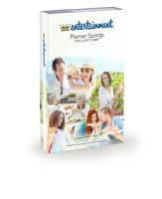

**[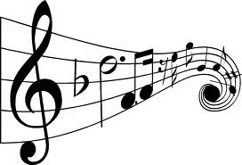](http://www.google.com/imgres?imgurl=http://www.wallpaperbasti.com/wallpapers/music/musical-notes/4.jpg&imgrefurl=http://www.wallpaperbasti.com/music/musical-notes/stylish-musical-notes-pic-23604.htm&h=1023&w=1500&sz=141&tbnid=xniARvof-IhFqM:&tbnh=86&tbnw=126&prev=/search?q=music+notes&tbm=isch&tbo=u&zoom=1&q=music+notes&usg=__SfHBgZHgkBIkuBE1QRyXtF1cMZE=&docid=DpDZH5UKcv8xeM&sa=X&ei=gaHsUcr7NYW4qAHw_oHoDg&ved=0CE8Q9QEwAw&dur=609) SUPPORT OUR BANDS/ORCHESTRA AND SAVE UP TO 50% ON FAMILY FUN!**

***Dear Family and Friends of the Menomonee Falls Bands/Orchestras***

**The Entertainment 2020 Savings Book is being offered for sale by**

**the Menomonee Falls High School Band Bunch**.

**North Middle School and High School Band and Orchestra Students**

Profit from each book sale (approximately $11.50) will go to the Band Bunch Organization

**This book sells for $35.00 with savings that begin now and are good through November 2020!**

***There are great savings on dining, travel, shopping, entertainment and much more.***

Included in savings this year are everyday uses such as Subway, Sonic, Maxfield's, Pop's Custard, Sunset Playhouse

Marcus Movie Theatres, Dick's Sporting Goods, Burghardt's Jo Ann Fabrics, Hobby Lobby, Michael's and

Bank of Memories Flowers and Barnes and Noble. In addition, many fast-food chain restaurants along with casual and upscale dining restaurants in the Milwaukee area are also included. Several rental car companies, air travel and hotel discounts are available. Both local and nationwide tourist attractions such as zoos, museums, national retail chains, ski areas, golf courses and more are offered. Newer merchants include Red Box, Family Dollar,

Stir Crazy, RBG Bar, Bub's Irish Pub and Usinger's.

The **mobile app/digital savings code is returning** that allows customers to go paperless and simply show their phone to receive additional nationwide savings as one travels throughout the United State and Canada. Be sure to register your book on-line after purchasing has been credited, in order to receive these added discounts.

**The book *pays for itself almost immediately upon use.***

These books can also be ordered for most major out-of-town cities as well and make great gifts!

**\*IN ORDER TO RECEIVE BAND BUNCH CREDIT FOR ON-LINE SALES,**

**YOU MUST USE THE BAND BUNCH ACCOUNT #10505826**

**Visit fundraising.entertainment.com and clik on "supporter"**

**and enter the above sales code for any on-line sales.**

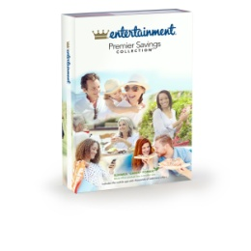

Books are *available now* with no pre-ordering necessary.

**For questions or if you would like to purchase a book, please contact:**

**Barb Nienow at 262 251-8968 Bnienow@sbcglobal.net**

**\*You may send a check inside an envelope to your student's band/orchestra director with a note indicating how many books you wish to purchase. Books will be delivered to your student's band/orchestra class within a few days.**

**Please mark on the outside of the envelope:  
Attention Barb Nienow "Entertainment Book Order"**

**Please include your student's name and ensemble group.**

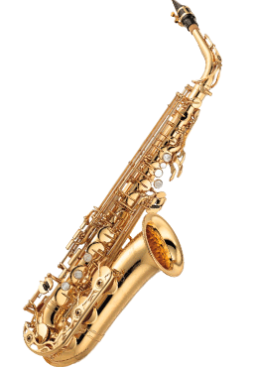**Buy 5 Books - Get 1 Free is also an option**

Please spread the word among family and friends.

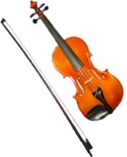**All Entertainment Book Orders must be turned in by Tuesday, October 1st.**

**Checks should be made payable to the Menomonee Falls Band Bunch**