**SAVE THE DATE**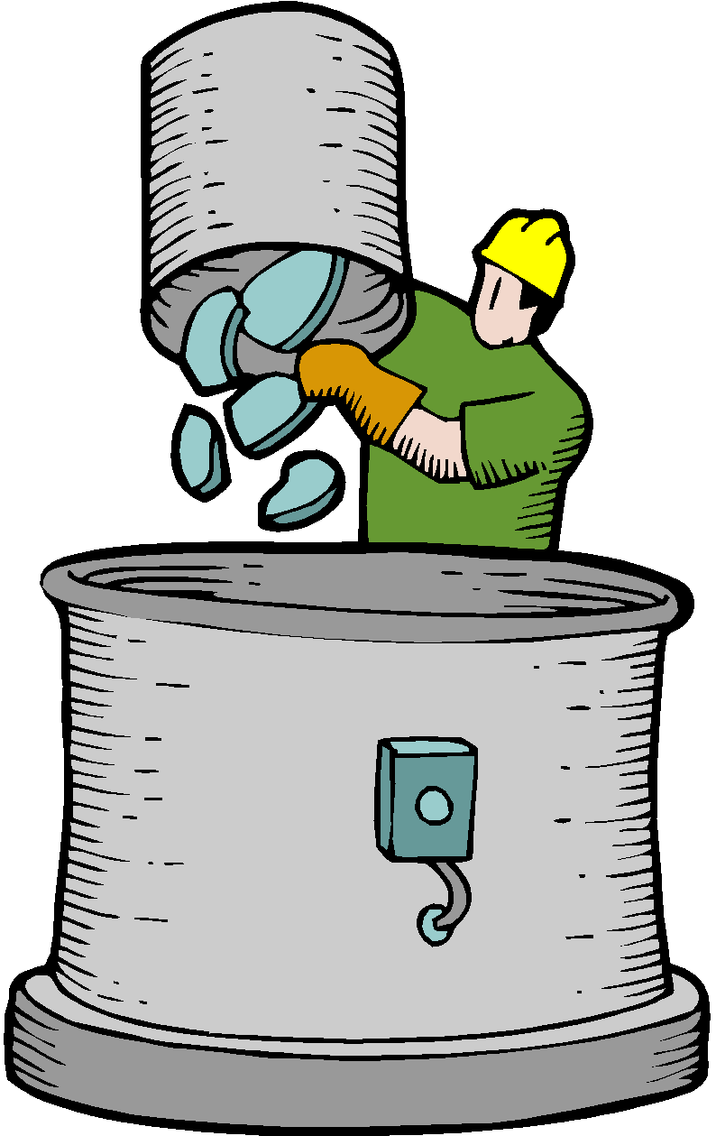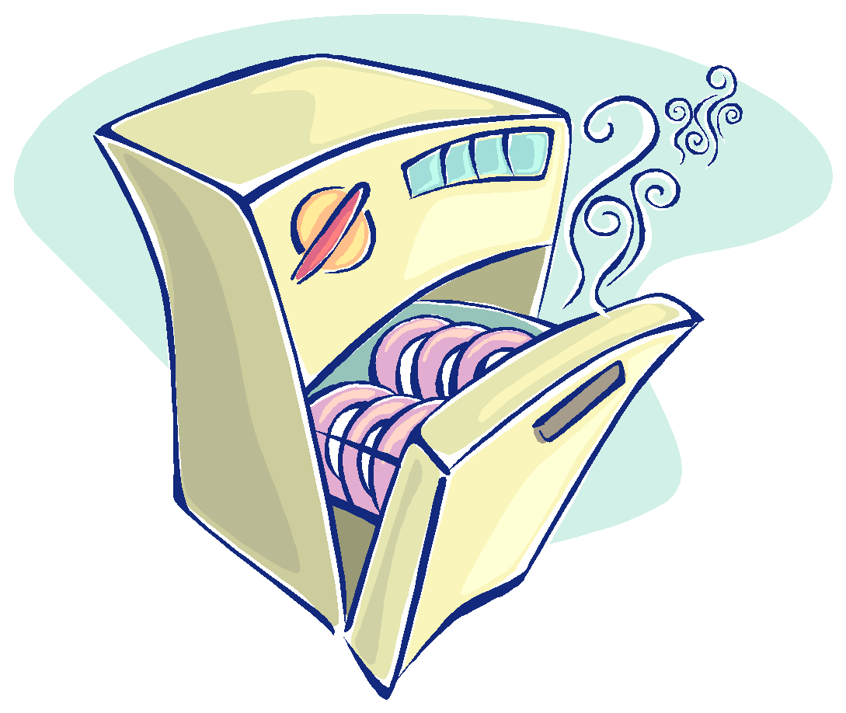

**SPRING METALS RECYCLING DRIVE**

**SATURDAY - June 1st, 2019**

The Menomonee Falls School District in conjunction with the Band Bunch Booster organization will be holding their semi-annual Fall Metals Recycling Drive at the High School Stadium parking lot on

**Saturday, June 1st from 8 a.m. - 12 p.m.**

As you come across unwanted items in your basement or garage, this is a great way to unload that scrap metal for free while helping to raise funds and support our school district's band, orchestra and music program.

**What can be donated?** Old appliances, snow blowers, lawn mowers, grills, shelving, fire pits, fireplace sets, patio furniture, old siding, stainless steel, brass, electrical wire, plumbing pipe, old Christmas lights, window screens, bicycles, swing sets, and much more. Just about anything goes! If nothing else, please simply save your aluminum cans.

*FYI: No television sets, computer monitors, furniture, mattresses or glass doors.*

If you have questions, please contact **Jon Mitchell at (262) 229-5698.**

**Thank you in advance for your support. Every little bit helps!**

**This recycling event is free and open to the community so help**

**spread the word to family, friends and neighbors.**