METALS RECYCLING DRIVE

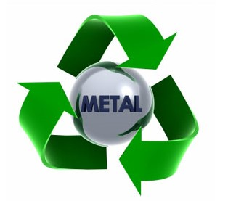

SATURDAY, June 2, 2018

8:00am – 12:00 noon

Menomonee Falls High School Stadium Parking Lot

(across from Pick n Save on Appleton Avenue)

The Menomonee Falls School District in conjunction with the **BAND *(and Orchestra)* BUNCH** booster organization will be holding their annual fall Metals Recycling Drive. All proceeds benefit the Menomonee Falls band and orchestra programs, and it’s **FREE** to you and the *entire* community! So spread the word and save your scrap metals!

WHAT CAN BE DONATED?

Old appliances, snow blowers, lawn mowers, grills, shelving, fire bowls, fireplace sets, patio furniture, siding, stainless steel, BRASS, COPPER, electrical wire, plumbing pipe, Christmas lights, window screens, bicycles, swing sets, aluminum cans… just about anything goes!

WHAT CAN’T BE DONATED?

TV sets

QUESTIONS?

Please call Lynn Cooksey at (262) 893-6143.

THANK YOU!

Every little bit helps.

